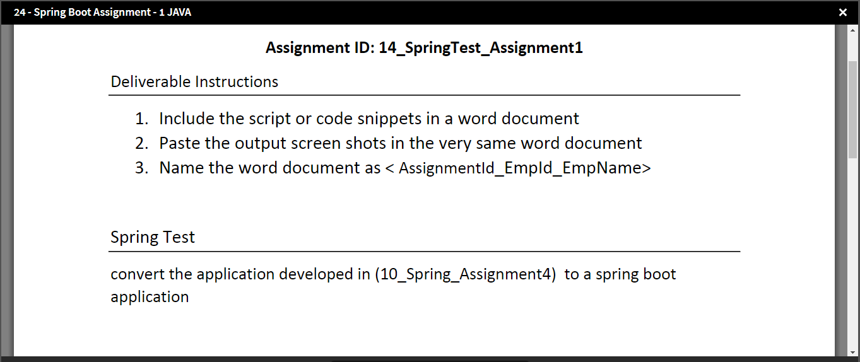

Assignment ID:10_Spring_Assignment4 Given Aside - 